Weather Trend Project

* Is your city hotter or cooler on average compared to the global average? Has the difference been consistent over time?

My city is hotter compared to global temperature and the difference is consistent over the years.

* How do the changes in your city’s temperatures over time compare to the changes in the global average?”

My city's temperature changes over time as global temperature changes, that changing temperature varies over the year compare to global temperature

Correlation between mgd_temp and mcd_temp is : .7359

* What does the overall trend look like? Is the world getting hotter or cooler? Has the trend been consistent over the last few hundred years?

From the data we can say global is getting hotter over the time. From the data seems to me that this trend has been consistent over the last few hundred years.

* Outline of project

SQL query was used to extract my city data from the city_data and join with global_data. I live close to Indianapolis. I used that city data in my project.

Here is the query I used it:

select

gd.year, gd.avg_temp as global_temp , cd.city, cd.avg_temp as city_temp

from global_data gd

join

city_data as cd on cd.year = gd.year

where cd.city = 'Indianapolis'

Data downloaded and imported it into google sheet.

Moving average calculated of avg_temp for global_data and city_data.

Used the average formula in google sheet for 10 years interval and dragged it all the way to the end of the data.

Calculated min, max and correlation between global_data and my city_data(Indianapolis)

I can easily visualize minimum and maximum temperature over the years.There is a positive correlation between my city temperature and global temperature.

**Observation:**

* Line chart was plotted with these variables: Year, global moving average temperature and city average temperature. Between 1985-1996 temperature decreased.

The maximum moving average city temperature was 12.462 in 1998, same year global moving average temperature was also maximum that was 9.55

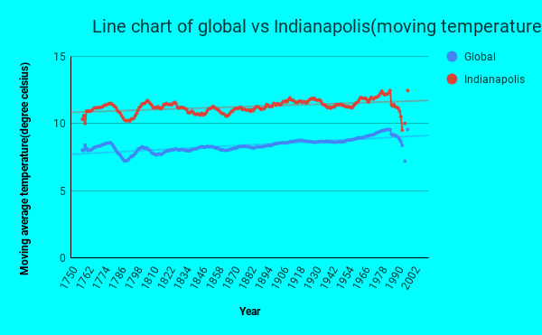

* Scatter plot.
* Minimum moving average temperature was 10.007 in 1760 and 1996 in Indianapolis and. global moving temperature was minimum in 1996, was 7.203.
* In 1998 temperature was maximum while in 1996 temperature is minimum.
* There is a positive correlation between my city temperature and global temperature.
* Correlation between Indianapolis and global temperature is 0.735 with moving average data
* Without moving average data correlation is slightly correlated that is 0.476.

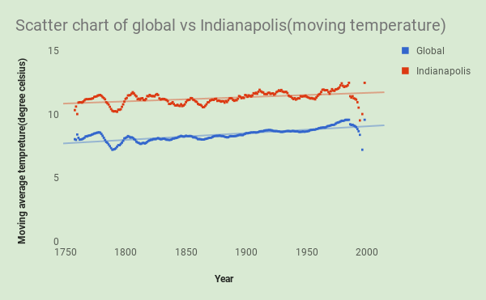

* Combo Chart

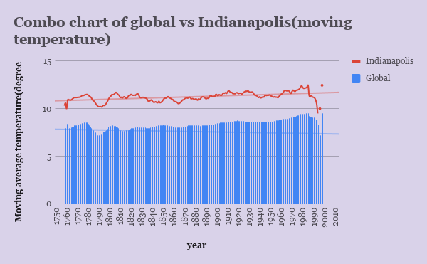

* Stacked column chart

